**Data Analytics Project**

ON

**Opioid-Related Deaths**

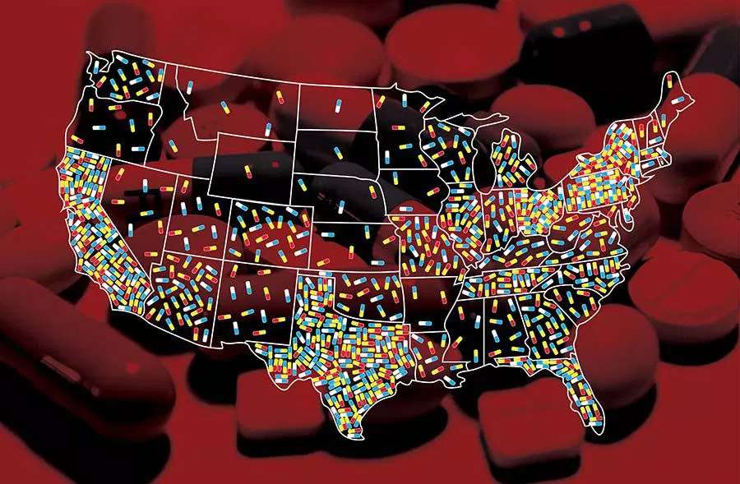

***More Frightening than Terrorism: The Opioid Epidemic***

**Submitted By:**

**Mario Espinosa**

**Jamie Quolas**

**Neha Singh**

**Carolyn Super**

**Zhenglong Wu**

**Table of Contents:**

**1. Executive Summary**

**2. Problem Significance**

**3. Data Source/Preparation**

**4. Hypotheses**

**5. Descriptive Analysis**

**6. Models**

**7. Quality Checks**

**8. Recommendations**

**Executive Summary:**

Addiction and overdoses associated with prescription and illicit opioids have been characterized by the U.S. Department of Health and Human Services as a national crisis. Since 2000, the rate of overdose deaths involving opioids has increased fourfold. In last three years **2015, 2016, 2017** opioid overdose deaths increased to **3,091, 42,249,** and **49,068** respectively, this number is greater than any other cause of deaths number including, deaths from suicide, road accidents, terrorism etc. Every day, more than **115** people in the United States die after overdosing on opioids. The misuse and addiction to opioids—including prescription pain relievers, heroin, and synthetic opioids such as fentanyl— has become a serious national crisis that affects public health as well as social and economic welfare. The Centers for Disease Control and Prevention estimates that the total "economic burden" of prescription opioid misuse alone in the United States is **$78.5 billion** a year, including the costs of healthcare, lost productivity, addiction treatment, and criminal justice involvement. This facts and findings motivated us to do our data analytics project on opioid overdose deaths. To pursue this analysis, the data has been gathered from CDC- Centers for Disease Control and Prevention.  The data included the death statistics along with many other factors like, population,state,crude rate,prescription along with the years from 2006 to 2014. Standard approach has been followed by performing the exploratory analysis, forming hypothesis and conducting the regression analysis on the data. The data has been modelled using 4 models and finding the one which predicts the data best and also is practically suitable. The key findings from our analysis suggest as:

1. The population increases opioid overdose death rate increases irrespective of other factors and it comes out to be a significant factor in our study.
2. Prescription rate also has impact on number of opioids overdose deaths but it’s not as significant as increase in population.
3. Analysis have identified both Michigan and Maine have good policies and treatment of opioids prescriptions as their opioid overdose death rates have decreased over the last 8 year while the population has increased over the year. This suggests that government official or health care policy maker can study what measure they are taking to combat with opioid problem and can implement those policy or measures to state with higher number of deaths like Florida.
4. The following states have the most opioid overdose deaths without any influence of population and prescriptions: West Virginia, Nevada, Utah, Maryland and Massachusetts.

**Problem Significance:**

In this project we want to study the relation between opioid overdose deaths with respect of number of prescription statewise in United States. We want to see some patterns or trends in data and want to give some inputs to government officials, health care professionals who are responsible for making health care related policies and regulation and responsible for its proper implementation.

In the late 1990s, pharmaceutical companies reassured the medical community that patients would not become addicted to prescription opioid pain relievers, and healthcare providers began to prescribe them at greater rates. This subsequently led to widespread diversion and misuse of these medications before it became clear that these medications could indeed be highly addictive. Opioid overdose rates began to increase. In 2015, more than 33,000 Americans died as a result of an opioid overdose, including prescription opioids, heroin, and illicitly manufactured fentanyl, a powerful synthetic opioid. That same year, an estimated 2 million people in the United States suffered from substance use disorders related to prescription opioid pain relievers, and 591,000 suffered from a heroin use disorder (not mutually exclusive).

**What do we know about the opioid crisis?**

Roughly 21 to 29 percent of patients prescribed opioids for chronic pain misuse them.

Between 8 and 12 percent develop an opioid use disorder.

An estimated 4 to 6 percent who misuse prescription opioids transition to heroin.

About 80 percent of people who use heroin first misused prescription opioids.

Opioid overdoses increased 30 percent from July 2016 through September 2017 in 52 areas throughout 45 states.

The Midwestern region saw opioid overdoses increase 70 percent from July 2016 through September 2017.

Opioid overdoses in large cities increase by 54 percent in 16 states.

This issue has become a public health crisis with devastating consequences including increases in opioid misuse and related overdoses, as well as the rising incidence of neonatal abstinence syndrome due to opioid use and misuse during pregnancy.

The practical application of our data analysis can be used by medical professionals in determining pain treatment options for their patients. In observing any correlation between an increase in prescription rates and an increase in deaths, we can reasonably conclude that a decrease in prescription rates would lead to a corresponding decrease in deaths. It can also be used by the federal government, providing the necessary knowledge to effectively distribute funds from the federal drug-abuse program to the various state-run programs. Assuming a key mission of the federal program is to reduce drug-related deaths, allocating funding to states that have a higher number of deaths in proportion to their population will provide the resources needed to combat the issue.

**Data Source/Preparation:**

The portion of data containing information about state populations and opioid-related deaths was extracted from the National Center for Health Statistics and compiled with additional information from the CDC’s WONDER database concerning the number of prescriptions. Accompanying the variables deaths, state, population, and prescriptions were various ratios that provided little additional insight to our analysis. In our data, opioid deaths are defined as deaths in which the underlying cause was drug overdose. The drugs included in the variable are heroin, opium, other opioids, methadone, other synthetic narcotics, and other unspecified narcotics.

We were unable to perform analysis on the state of North Dakota. The data for all but one year presented were suppressed. In other words, according to the data, disclosing the information could lead to the disclosure of individual identities. We do not believe that excluding North Dakota impacted our analysis of the other states. Wyoming, Arkansas, and District of Columbia each had one year that data on the number of opioid-related deaths was unavailable. The one year of data was excluded from the analysis of those states. We do not believe it significantly impacted our models.

**Hypotheses:**

We have structured our hypotheses around two important implications of our data to the public.

H1a: βPopulation > 0

The first set of hypotheses concern the number of opioid related deaths in a state compared to the states’ population. This will inform us which states have the highest rate of death and answer the question of where the government should be allocating its resources to when assessing the funding of treatment centers, programs, and other projects related to the war on drugs.

H2a: βPrescription > 0

The second set of hypothesis correspond the number of prescriptions to the number of deaths and will tell us if the increase in opioid prescriptions are related to the rise in opioid related deaths, or if the rise in deaths is due to another factor not included in our data.

H3a: βYear  > 0

The second set of hypothesis identifies trends over the 8 years. Because of the addictive nature of opioid drugs, we expect the deaths to opioid overdose to increase each year.

**Descriptive Analysis**

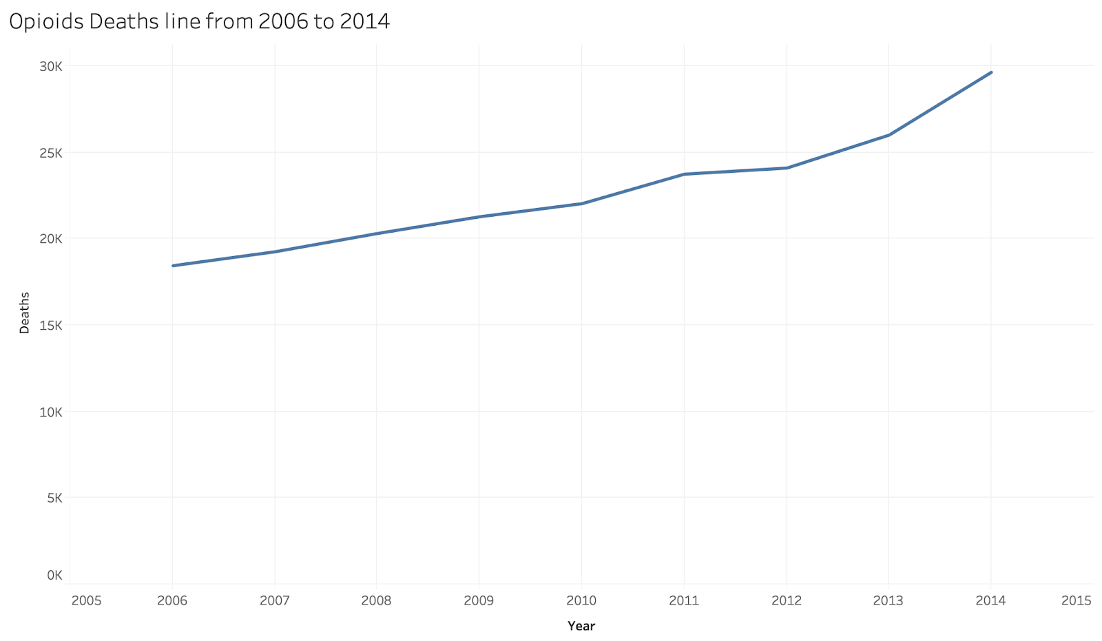

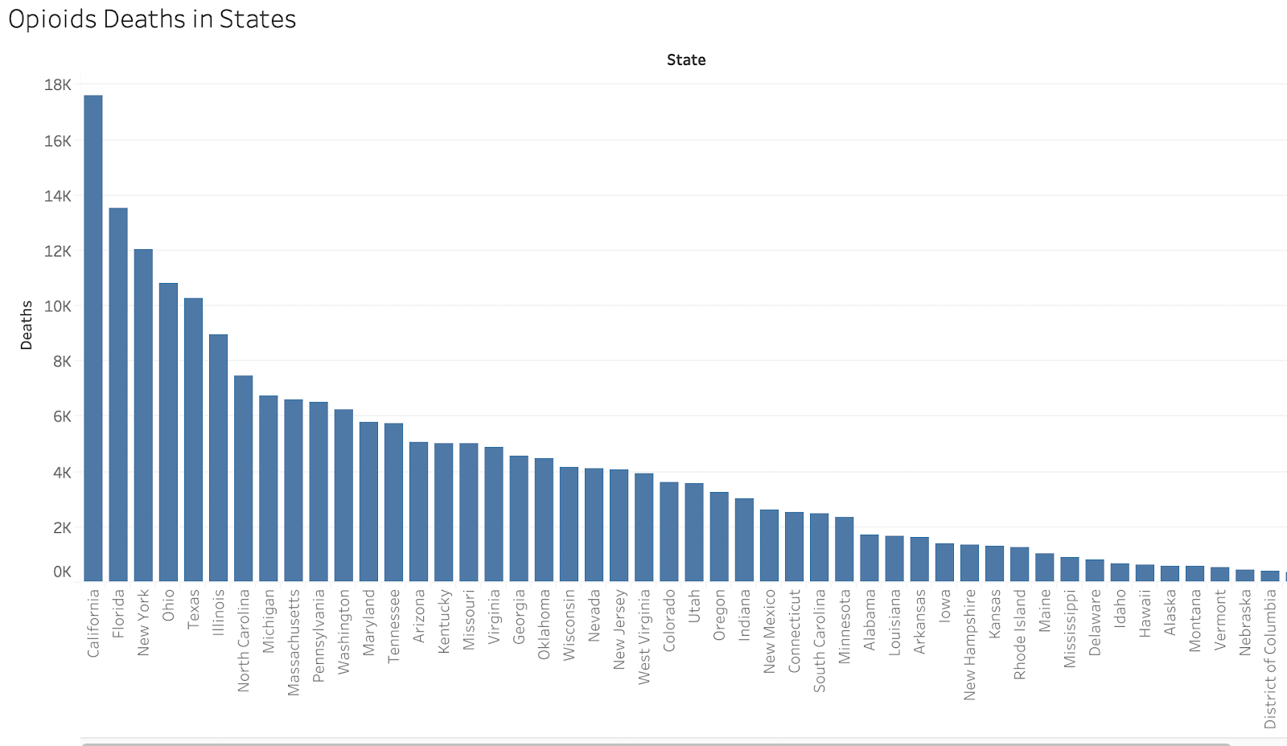

The number of opioid related deaths in the United States are steadily increasing at a relatively even rate across all years presented. The number of prescriptions increases steadily from 2006, peaking in 2011 at nearly 220 million. However, this trend reverses following 2011, with less than 200 prescriptions issued nationwide in 2014.

This graph shows how the trend of increasing prescriptions reverses in 2011. Prescriptions are show in millions.

A decrease of 20 million prescriptions issued seems like a large amount, but it is less than a 10% decrease in total prescriptions. We think there may still be some correlation between prescriptions issued and opioid-related deaths, but given this preliminary analysis, it is clear there are other factors at play as well.

The population across all states is increasing by a nominal amount each year, and there is a positive linear correlation between population and number of deaths as would be expected. Our analysis will tell us what percentage of the increase in deaths is attributable to population increase and what percentage is a result of other factors.

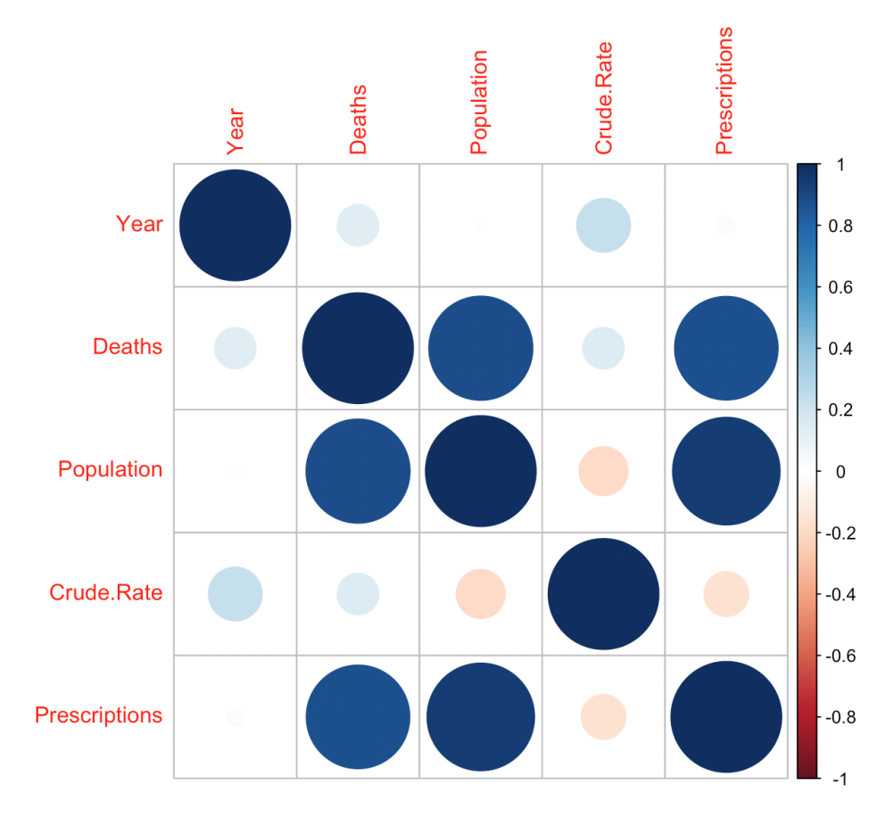

The Corplot for correlation of all variables. [Overdose is All Drug Overdose Deaths]

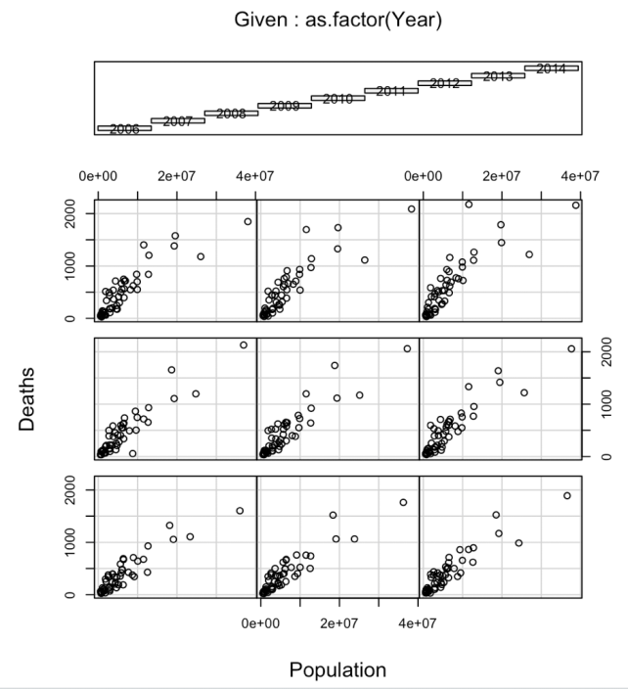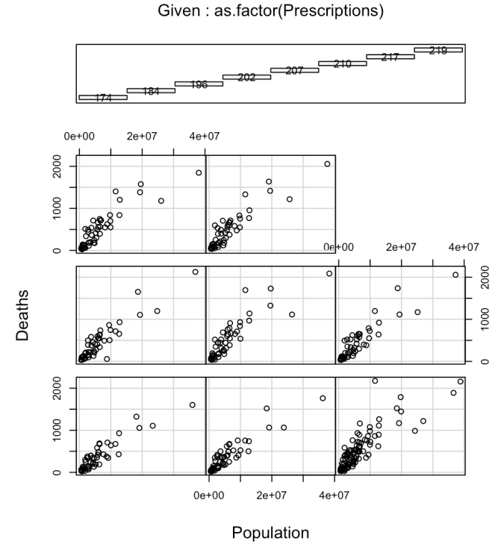

The relationship between Deaths and Populations depend on different year or different prescription. [2006 - 2014]

**Models:**

Observing the exponential nature of the opioid death histogram, we try to normalize the data through a log function.  All models use the logarithm of opioid deaths as a dependent variable and population and prescription of opioid drugs as predictor variables.  In the temporal model, we add the Year as the time variable.

***Basic Model***

Deaths =  βPopulation +  βPrescriptions + 𝜀

This model is the basic model that use linear regression to explain the opioids death based on population and prescriptions. (The output is in the Figure 1 in Appendix)

***Exponential Model***

Log(Deaths) =  βPopulation + βPrescriptions + 𝜀

Due to the Deaths is not normal distributed; we did some transformation and build the second model. This model uses a non-linear regression and takes the logarithm of opioid deaths as function of population and prescription. (The output is in the Figure 2 in Appendix)

***Panel Model***

Log(Deaths) =  βPopulation + βPrescriptions + 𝜀

This model explores the panel effects of various states and year. The pooling model confirms the exponential model; while the fixed model explores the differences between each state. Finally, the random model show the spread of differences between each state. (The output is in the Figure 4 in Appendix)

***Mixed* Model**

Log(Deaths) =  βPopulation + βPrescriptions + β(State) +  𝜀

This model combines the fixed effects and random efforts into a single cohesive model. It has similar results as the previous model. (The output is in the Figure 5 in Appendix)

***Temporal Model***

Log(Deaths) =  βYear + βPrescriptions  + 𝜀

In the the temporal model, we explore the trends of each state across the years, 2006-2014. We exam each state logarithm of opioids deaths as a function of year, population and prescription. We found 19 states that have significant variables in the model (see Appendix 1). For the lag analysis, we randomly picked four states with significant variables and four states with non-significant variables in the temporal analysis. We no presences of significant variables in the lagged model for all 8 states.

**Quality Checks:**

Model Comparison

***1. Exponential Model***

A log-linear model is used for the first and second hypothesis, the exponential Model is Heteroscedastic and Non-linear on the chart, and also the QQ plot doesn’t look normal, especially at high theoretical. In the shapiro.test, the p-value in residuals of exponential model is less than 0.05; we can reject H0 that residuals are normal. Therefore, this model is a bad model. (The output is in the Figure 2 in Appendix)

***2. Panel Model***

In the panel model, we built pooling, fixed and random models. In the plmtest of pooling model, the p-value < 0.05, which means data, shows panel effect.  In the pFtest between fixed model and pooling model, the p-value < 0.05, which means fixed model, is better than pooling model. In the phtest between fixed model and random model, the p-value is 0.08(>0.05), we cannot reject fixed model is worse than random model.With the fixed effect, the median of the residuals were just slightly below zero (-.005) and only a small drop in the adjusted R^2 from the R^2 ensued. (The output is in the Figure 4 in Appendix)

***3. Mixed Model***

Based on a visual test, the residuals seem to be centered around zero which indicates that they are not biased. Also, the variance is pretty evenly spread with minor concentrations around 6 and 7. This indicates for the most part it is homoskedastic. This plot shows no real patterns so it shows a pretty random spread above and below zero; indicating that it is multivariate normality. (The output is in the Figure 5 in Appendix)

***4. Temporal Model***

In Temporal model, we build 51 OLS regression models for 51 states, and then we pick out Michigan, which are the only significant models in these 51. In the Bartlett test, the p-value < 0.05, we must reject H0 that the residual and fitted values have equal error variance, the residuals are heteroskedastic. (The output is in the Figure 6 in Appendix)

All in all, The mixed model is the best model, because it captured the exponential model and represented the panel effects. And it is homoskedastic and multivariate normal.

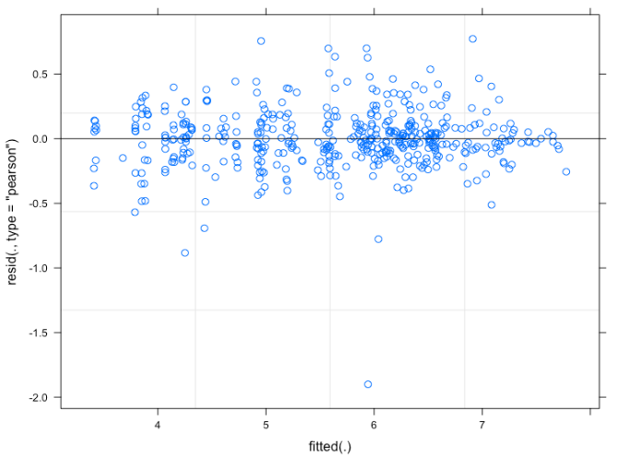

**Outcome:**

In the model we built, we can figure out that in the mixed model :

* When other variables are constant, 1 million population increases, 3.15% of Opioid death increase in a year.(not significant)
* When other variables are constant, 100 thousand prescription increases, and 1.47% of Opioid death increase in a year. (significant)
* Without any effect of Population and Prescription, we expect that 111.3 [exp(4.712)] Opioid death in a year.
* The random effect of Different States on Death is at 0.6737 standard deviation, which means different state will have almost 23% different opioid deaths without any other effects.

**RECOMMENDATIONS:**

Based on our analysis, the following states have the most opioid overdose deaths without any influence of population and prescriptions: West Virginia, Nevada, Utah, Maryland and Massachusetts. Our recommendation to their health professionals and state policymakers is to prioritize their allocation of resources for state-run drug programs for a greater proportion of funding for these states if the goal is to be effective in reducing the number of opioid-related deaths. In addition, we have identified both Michigan and Maine have good policies and treatment of opioids prescriptions as their opioid overdose death rates have decreased over the last 8 years. Other states should use their policies and treatment on opioid as a benchmark for example Maine’s New Opioid Prescribing Law has this few interesting points that can be implemented in other state too:

* Doctors will be monitoring a database called the “Prescription Monitoring Program” when they write prescriptions for opioid pain relievers
* People taking opioids for chronic pain may be asked to come to their doctor’s office more frequently for visits or other types of monitoring tools.
* Some people already taking opioids for chronic pain will be asked to work closely with their doctor to slowly decrease their dose of medication.

Michigan providers will now be required to check the state’s prescription database before they prescribe painkillers and powerful medications, under legislation by Michigan Lt. Governor Brian Calley. The legislation, signed into law, will also put a limit on the number of opioids prescribed to patients for acute pain and establish a “bona fide physician-patient relationship before prescribing controlled substances.” Further, the law specifies specific penalties for providers who fail to meet these requirements.

<https://www.affirmhealth.com/blog/opioid-prescribing-guidelines-a-state-by-state-overview> this is the link where people can go and compare state wise diffrence in laws regarding opioid and what different this state are doing.

Appendix A

***Basic Model:***

|  |  |
| --- | --- |
| https://lh4.googleusercontent.com/kWiSsQ6lcPP53Bdc5thR39r-DVssmrev1IIc0uHEdmWRwTqBZU6nnXVbLGnCOInkvaJMKbuvDDV4V_z-toyRkN3Y1v1SC1QlIeEHkC2l-5F3QwuiqQRlUwY2P8CvoO-i15IvutAZ    https://lh5.googleusercontent.com/B_0oDybp3urvjKxsMoVJJHEWrYIk4nuOWgJI6o86P_faP9VE-5-03ykDV077v5nIcTrwkNBkGtItJ1O-UoJk-zn_1T9OTXRyuRyXxv80pE7Qa7IqJ9lI90YTXYLt-RosNhpqDTBe | https://lh3.googleusercontent.com/OMapF1l5Tg74ej8wrX8Q9mA6gWdDK1MAWZBUhWxa-sXa6x6gpeTF8z6pGkghi4fX038r3LoI6Tz_MjR0F7nvYmxW9Rz79yF9i6Nydx2vFzgusEPMLNct-D7hEdwt0LyYhmsZSqKg  https://lh6.googleusercontent.com/cDn0iKKCNJzaIffvIR4zocKFqVSKGz6JmkFyeneJQJSY9yMIXlVpMmsjxojj_DLgg4DfqX1PWEdTXuDN16_IxkqGYteTCPuB9V1tGAuIYQqMEr7sfnAfNNEBnXUm0xehPoWQdVE8  https://lh3.googleusercontent.com/gttMAXbipIdkpJ_PrrOLMFczLVegMrLhWwpWwV7ZaTCjqIA2YaHdtKWeDaz-R3tHaOpFt_XsS9XskMXfxCM1mNdhNyBWz_vGBruktZuQYJAhgy-n9a2aqoviOMFg3W-805aWLG2i |

Figure 1. Basic Model

***Exponential Model***

|  |  |
| --- | --- |
| https://lh3.googleusercontent.com/M5G8ePoll6eBawQpa8zSJHfUmzCyjyHfz82FyHvRZsfn0I87tRzRq6SiKgF6z7hCNZWwH7our-0TayxyVlpUldwbhQn3b5DwMUm1O0mgkBt5AI-mV0DMWPNtHgzslsr0VNrMnqT9  https://lh3.googleusercontent.com/4hsU-UsoGWqIKI5CYeteTMoYrOBdowy8aL6OB44kb-GP5zFi53ZvU8jTX4gti_yOWmSF3IqpACtg277Ff9qGuOKS_SYhcMiyJnZPyh6S0n-DQphX0J1-ARXy4VC7wlt0ZYX_0hzh | https://lh4.googleusercontent.com/G-d_sDpUdU1MiHPg07FC4xaZs6n6vb0r89QgHVNj8_7x5gG_s5IkF54k7oEPzpv3EXqePxa8yLXIslkCYeuKwXfdmDf2KPh8Chdbbp4ZkAJvHlzwgyZ0KA9xmSI_AHO4bM9SbHe4  https://lh6.googleusercontent.com/uQ2jBhVvor3Xo8LkF_hRlnmGVCUTY3VawLieqFs4vgKPl1M5OGsnlEk0FlhIgQ6yAlq7F8t0JY9mRoSPCIc4wV4Fq1ZBUlj_VMHjQcvUoswnxI5K5MQhQSsf7GowIwM7mBzjsSMY  https://lh4.googleusercontent.com/ggyCeO2LBbU7CBuhq4lby-lqD-P6_k-eeb_lxGLn6cI-DbCaHo6IfIUK7Vm9uj4luGOyG6FhWigDFw_MvRjJed7pl-bnfBLSc_wjhZNRYyEfDGPsZzq4Y9wa3w0Z_3e_PoNdrmls |

Figure 2. Exponential Model

Evaluate:

* From the chart, we can see the model is Heteroscedastic and Non-linear.
* QQ plot doesn’t look normal, especially at high theoretical.
* In the shapiro.test, since p-value <0.05, we can reject H0 that residuals are normal.

Interpretation:

* Population is a significant variable increasing Opioid Death.
* When other variables are constant, 1 million population increases, 2.42% of Opioid death decrease in a year.
* When other variables are constant, 100 thousand prescription increases, 2.24% of Opioid death increase in a year.
* Without any effect of Population and Prescription, we expect that 110.7  [exp(4.707)] Opioid death in a year.

***Panel Model***

|  |  |
| --- | --- |
| https://lh5.googleusercontent.com/PIY6YVo8Hlj_GmEESmLgqDz-3GZ2XYa593RWlDa77zJa6V-BOMkgsr3FIbt3XV0YAdK2q6-r-UuLH7DdYoQzoLsqvPMvKqHuVgO4mydF19KHsAGKIfWA-Dq2VzE7RV_R1-NfboRP | Pooling Model Interpretation:   * Prescription is a significant variable increasing Opioid Death. * When other variables are constant, 1 million population increases, 2.42% of Opioid death decrease in a year. (not signicant) XXX * When other variables are constant, 100 thousand prescription increases, 2.24% of Opioid death increase in a year. * Without any effect of Population and Prescription, we expect that 110.7  [exp(4.707)] Opioid death in a year. |
| https://lh4.googleusercontent.com/zapU-hpidbwuKPqZ9J9DSXxD0ucwaLhJZaRvp5PZRVDQJrz77Eq7rGwhiNr-oqAi9OHP5VubjSkKDvc26DaMsklf-ZbRBmPS07cRWaMtNqBmOJE5OMDL8aRK6xgJCLdByKW4ws7b | Within Model Interpretation:   * Median is very close to 0 as we would expect * When other variables are constant, 100 thousand population increases, 1.17% of Opioid death increase in a year. * When other variables are constant, 100 thousand prescription increases, 1.13% of Opioid death increase in a year. * Without any effect of Population and Prescription, we expect that (25.804, 250.153) Opioid death in a year. [(exp(SouthDakota),exp(WestVirginia))]. This would be a good table to show Top 5 or Top 10 states that have the highest Opioids Death without effect of Population and Prescriptions. |
| https://lh5.googleusercontent.com/i7_D_mfMy4epstBawlgmr_S1xDK6VkHUQtHJUDeM24wYjBUHVCQJgDIPUot5Ssas_MAJbIjuoMQMu1uKqkdOcF8aPSe488FYGbAeBWWizaNjnjoD56kjdLb3uOitkfE4hYAIQpQt |  |
| https://lh3.googleusercontent.com/gS59TrCmCtIJyJg-Dij48jA3hmPVbHkbdUk3lN70yT7yzlWrtKAUmIGfmbDKbHYKQIVhAQzrvY7a_js2kVcKsyGKFt5li3jERdNwdvNOSic0qppaPVBkb5j5NnANKB7zDwd3tgLO |  |

Figure 4. Panel Model

|  |  |  |  |  |  |  |
| --- | --- | --- | --- | --- | --- | --- |
|  | Estimate | Std. | Error | t-value | Pr(>|t|) |  |
| WestVirginia | 250.153568 | 5.52 | 0.126235 | 43.7445 | 2.20E-16 | *** |
| Nevada | 249.17962 | 5.52 | 0.1518 | 36.3517 | 2.20E-16 | *** |
| Utah | 219.818235 | 5.39 | 0.153246 | 35.1905 | 2.20E-16 | *** |
| Maryland | 205.371801 | 5.32 | 0.283722 | 18.7678 | 2.20E-16 | *** |
| Massachusetts | 203.330554 | 5.31 | 0.318884 | 16.667 | 2.20E-16 | *** |
| Oklahoma | 193.537056 | 5.27 | 0.202152 | 26.0471 | 2.20E-16 | *** |
| NewMexico | 188.596158 | 5.24 | 0.125968 | 41.5947 | 2.20E-16 | *** |
| Kentucky | 171.397942 | 5.14 | 0.234291 | 21.9556 | 2.20E-16 | *** |
| Washington | 169.610223 | 5.13 | 0.326236 | 15.7355 | 2.20E-16 | *** |
| Oregon | 151.024489 | 5.02 | 0.199754 | 25.1181 | 2.20E-16 | *** |
| Missouri | 148.76353 | 5.00 | 0.293391 | 17.0501 | 2.20E-16 | *** |
| Colorado | 148.228203 | 5.00 | 0.2501 | 19.987 | 2.20E-16 | *** |
| Wisconsin | 146.76182 | 4.99 | 0.278608 | 17.9062 | 2.20E-16 | *** |
| Arizona | 145.975529 | 4.98 | 0.311534 | 15.9965 | 2.20E-16 | *** |
| Connecticut | 133.708492 | 4.90 | 0.186278 | 26.2815 | 2.20E-16 | *** |
| Tennessee | 115.300297 | 4.75 | 0.335601 | 14.1464 | 2.20E-16 | *** |
| RhodeIsland | 110.295376 | 4.70 | 0.095567 | 49.2134 | 2.20E-16 | *** |
| NewHampshire | 107.838205 | 4.68 | 0.102509 | 45.6607 | 2.20E-16 | *** |
| Virginia | 106.581612 | 4.67 | 0.384124 | 12.1547 | 2.20E-16 | *** |
| NorthCarolina | 100.731947 | 4.61 | 0.456967 | 10.0937 | 2.20E-16 | *** |
| Minnesota | 97.9961312 | 4.58 | 0.264198 | 17.3541 | 2.20E-16 | *** |
| SouthCarolina | 92.0814029 | 4.52 | 0.234583 | 19.2796 | 2.20E-16 | *** |
| Illinois | 89.6530302 | 4.50 | 0.60858 | 7.3876 | 8.97E-13 | *** |
| Arkansas | 88.2286729 | 4.48 | 0.16471 | 27.1989 | 2.20E-16 | *** |
| Iowa | 84.6203685 | 4.44 | 0.164892 | 26.9156 | 2.20E-16 | *** |
| Maine | 84.4183673 | 4.44 | 0.102971 | 43.078 | 2.20E-16 | *** |
| Ohio | 82.1445089 | 4.41 | 0.554205 | 7.9546 | 1.92E-14 | *** |
| Michigan | 80.470769 | 4.39 | 0.477318 | 9.1928 | 2.20E-16 | *** |
| Kansas | 77.2320866 | 4.35 | 0.156765 | 27.7282 | 2.20E-16 | *** |
| NewJersey | 75.1863727 | 4.32 | 0.423104 | 10.2102 | 2.20E-16 | *** |
| Indiana | 71.798458 | 4.27 | 0.321798 | 13.2812 | 2.20E-16 | *** |
| Delaware | 69.3452742 | 4.24 | 0.092211 | 45.9716 | 2.20E-16 | *** |
| Georgia | 62.1679753 | 4.13 | 0.463083 | 8.9181 | 2.20E-16 | *** |
| Alaska | 61.0720308 | 4.11 | 0.092947 | 44.2408 | 2.20E-16 | *** |
| Louisiana | 59.0679809 | 4.08 | 0.23474 | 17.3754 | 2.20E-16 | *** |
| Hawaii | 53.9059036 | 3.99 | 0.104565 | 38.1317 | 2.20E-16 | *** |
| Alabama | 52.5814292 | 3.96 | 0.257727 | 15.3743 | 2.20E-16 | *** |
| Idaho | 52.0917715 | 3.95 | 0.109943 | 35.9551 | 2.20E-16 | *** |
| Vermont | 51.6761831 | 3.94 | 0.086971 | 45.3598 | 2.20E-16 | *** |
| Pennsylvania | 51.0761676 | 3.93 | 0.600329 | 6.5519 | 1.78E-10 | *** |
| Montana | 50.5492951 | 3.92 | 0.094072 | 41.7014 | 2.20E-16 | *** |
| Mississippi | 47.0538175 | 3.85 | 0.166985 | 23.0637 | 2.20E-16 | *** |
| NewYork | 46.7861865 | 3.85 | 0.931638 | 4.1278 | 4.47E-05 | *** |
| District of Columbia | 42.0373286 | 3.74 | 0.091664 | 40.7854 | 2.20E-16 | *** |
| Wyoming | 38.7698545 | 3.66 | 0.090672 | 40.3392 | 2.20E-16 | *** |
| Nebraska | 33.8087958 | 3.52 | 0.118463 | 29.7201 | 2.20E-16 | *** |
| NorthDakota | 29.694861 | 3.39 | 0.247746 | 13.6873 | 2.20E-16 | *** |
| Florida | 29.056029 | 3.37 | 0.891962 | 3.7773 | 0.0001829 | *** |
| SouthDakota | 25.8042705 | 3.25 | 0.090458 | 35.9344 | 2.20E-16 | *** |
| Texas | 7.89421332 | 2.07 | 1.183572 | 1.7457 | 0.0816452 | . |
| California | 2.43817059 | 0.89 | 1.772557 | 0.5028 | 0.6153827 |  |

***Mixed Model***

|  |
| --- |
| https://lh6.googleusercontent.com/yDBGj0K8B_ZXnn2-dUluamkQsmCLBR2YuEQJKVnQkdsmeR4JFLFJH6YfxtOURDm6Fvl-QeQRnVCEzUDozrZuZfmfvV92Qu7Q9BTRv1HAzsF4eKXj06k4TIegglSdzfAPFv75RITv |

Figure 5. Mixed Model

Fixed effect: Population, Prescription

Random effect: State to Intercept

Interpretation:

* Median is not exactly zero.
* When other variables are constant, 1 million population increases, 3.15% of Opioid death increase in a year.(not signicant)
* When other variables are constant, 100 thousand prescription increases, 1.47% of Opioid death increase in a year. (significant)
* Without any effect of Population and Prescription, we expect that 111.3  [exp(4.712)] Opioid death in a year.
* The random effect of Different States on Death is at 0.6737 standard deviation, which means different state will have almost 23% different opioid deaths without any other effects.

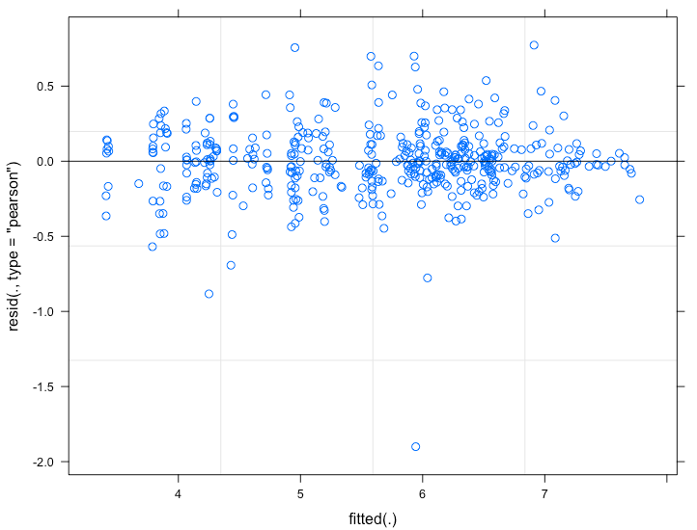

Based on a visual test, the residuals seem to be centered around zero which indicates that they are not biased. Also, the variance is pretty evenly spread with minor concentrations around 6 and 7. This indicates for the most part it is homoskedastic. This plot shows no real patterns so it shows a pretty random spread above and below zero; indicating that it is multivariate normality.

***Temporal Model***

|  |  |
| --- | --- |
| https://lh5.googleusercontent.com/yDFKZDeM1HH4wkJ0HQlO2pnjFwVVDJi5WOfv3kpRaqsnn6aQTULys9xqAjq0k5U_lkkeMz92YD-yIW7fKWSpbFDQM5L4w-ifvIw7xUHuMTU43t-g3Oe3zudyd9XgSIxXCpgCT91R | Bartlett test of homogeneity of variances  data:  list(tm1$residuals, tm1$fitted.values)  Bartlett's K-squared = 7.7709, df = 1, p-value = 0.005309  > vif(tm1)          Year Prescriptions      6.440052      6.440052 |
| https://lh5.googleusercontent.com/_3yJP8ZKhQJ1ZpvwtYaq-4cjSDFCChKACkEo6sb45S7LoO8WVCY33p2k61J7DH6kNo-nuMaXr7dkAb_yLN3ngfY8mVjnF2OARiXNedhKafJzh2r0QNOasJ3uzpezqjXiMTAv45Tr | https://lh4.googleusercontent.com/c-Bhsq996pkEkxzShVtXNp1ser4-jwrDofbowV0pZIoAJB6Ob2cfIRXEokeH_ODQCVvEJKO04hI7NqCnXND5v7Iyn55pofTbs_cLdaMUHhE6fpoCOzZtGS_ZBBnCU7rMj50I7KQJ |

Figure 6. Temporal Model

Temporal Analysis by each state

Interpretation: (Blue Text) States indicates strong significant results for the independent variables (Florida, Maine, Michigan). These are the states that need some attention when it comes to trying to reduce opioid impact. There could possibly be programs, funding, or government intervention implemented to help identify

|  |  |
| --- | --- |
| https://lh3.googleusercontent.com/WVu6qo2xrqZcE13L3hpzheVeTu7vkJQApM_R-fbSmL5zPEd_fRMCcTFy6ls3sQ8fHNaqFTQWEdMHlgS4i8UOD-OZye6OX_v7lWOztKZbwmW0Hld0oMyhChhDlhh92dqpLkXjnSIh | Interpretation:   * When other variables are constant, 1 Year increase, 942% of Opioid death increase in a year * When other variables are constant, 100 prescription increases, 1.76% of Opioid death increase in a year. (significant) * Without any effect of Year and Prescription, we expect that 0  [exp(-20110)] Opioid death in a year. |
| https://lh4.googleusercontent.com/9ibVz0Amg7ASDEhbYrHFEvjzzvNKegV1GB0qG0eJjyXJ9Zc4GbEFZ_50Y_zrr6PMfH0s9bX-u5xR1JZw5qXu2ijVAsbykPDlNppj1OVhuhPWDLt313wA6Z4Y_4VeOR61i99x1jvw | Interpretation:   * When other variables are constant, 1 Year increase, 642.2% of Opioid death increase in a year * When other variables are constant, 100 prescription increases, 3.47% of Opioid death decrease in a year. * Without any effect of Year and Prescription, we expect that 0  [exp(-12390)] Opioid death in a year. |
| https://lh5.googleusercontent.com/yDFKZDeM1HH4wkJ0HQlO2pnjFwVVDJi5WOfv3kpRaqsnn6aQTULys9xqAjq0k5U_lkkeMz92YD-yIW7fKWSpbFDQM5L4w-ifvIw7xUHuMTU43t-g3Oe3zudyd9XgSIxXCpgCT91R | Interpretation:   * When other variables are constant, 1 Year increase, 10900% of Opioid death increase in a year * When other variables are constant, 100 prescription increases, 2.67% of Opioid death decrease in a year. (significant) * Without any effect of Year and Prescription, we expect that 0 [exp(-216300)] Opioid death in a year. |
| https://lh5.googleusercontent.com/ILJcughiXiKPnpbS-VExcJcKfV2XMLqWajN-0yI9X_-6TKAOU02uB5FccTwUfvkmgWrR7xcgzXdFKcBN40MYX4hG6dvo_gz07LMF863xAvRaxUgm-aGrF2-yQ5_g-ZS_-rfjyte6 |  |

___________________

States with not significant variables...

Arizona  Arkansas  California  Connecticut

Georgia  Hawaii  Idaho  Indiana

Iowa  Kansas  Kentucky  Massachusetts

Minnesota  Mississippi  Montana  Nebraska

New Jersey  New Mexico  Oklahoma  Oregon

Rhode Island  South Carolina  South Dakota[  Texas

Utah  Vermont  Virginia  West Virginia

Wisconsin  Wyoming  North Dakota

Lag Analysis

Chose 4 states with not significant variables...lag analysis still did not reflect any significant variables.

|  |  |
| --- | --- |
| [1] Arizona  https://lh3.googleusercontent.com/kKABjsw1ZL8FmSatzVrtr9lKgJCqgCDWH-XZ7VvGo2T0OU8lTI9zp3WqwOwSqdju9Saq9H1lqLvnQ3l75SCnmS9MFdrUwLIXGmpnH8lws2dRiY8YbKctBYNUwJg2KxN_vrYtaxuu  Call:  lm(formula = Deaths ~ Year + Population + Prescriptions + lag1Deaths,     data = temp)  Residuals:    100    150 199    249 299 349    399  -1.662  6.594 -6.318 -2.362  8.617 -7.875 3.006  Coefficients:                 Estimate Std. Error t value Pr(>|t|)  (Intercept)    1.110e+04 4.548e+04   0.244 0.830  Year          -5.452e+00 2.332e+01  -0.234 0.837  Population     2.507e-04 2.609e-03   0.096 0.932  Prescriptions -4.842e-04  9.934e-04 -0.487 0.674  lag1Deaths    -9.137e-02 2.281e-01  -0.401 0.727  Residual standard error: 10.89 on 2 degrees of freedom   (3 observations deleted due to missingness)  Multiple R-squared:  0.6408, Adjusted R-squared:  -0.07753  F-statistic: 0.8921 on 4 and 2 DF,  p-value: 0.5893 | [1] California  https://lh3.googleusercontent.com/_jvoaUtvYoHdGSBIFR2CN_0Svj_62Lz7mh2KsyAL1zfDuvTy8GJQTtHdWwBLOXOmJ0uJ056YnXfSAbBn4G7vIoy9nfbtBd1NCuHb-q8XlYZaGzIZNs-U4rgu4MjENQsy2pxFbx__  Call:  lm(formula = Deaths ~ Year + Population + Prescriptions + lag1Deaths +     lag2Deaths, data = temp)  Residuals:     103    153 202     252 302 352     402  -93.804 147.091 -15.927 -22.371 -25.270   8.730 1.551  Coefficients:                 Estimate Std. Error t value Pr(>|t|)  (Intercept)   -2.021e+05 1.363e+06  -0.148 0.906  Year           1.105e+02 7.137e+02   0.155 0.902  Population    -2.973e-04 1.942e-03  -0.153 0.903  Prescriptions -4.263e-04  3.977e-04 -1.072 0.478  lag1Deaths     3.446e-01 6.489e-01   0.531 0.689  lag2Deaths     7.039e-01 1.044e+00   0.674 0.622  Residual standard error: 178.6 on 1 degrees of freedom   (4 observations deleted due to missingness)  Multiple R-squared:  0.6224, Adjusted R-squared:  -1.265  F-statistic: 0.3297 on 5 and 1 DF,  p-value: 0.8579 |
| [1] New Mexico  https://lh4.googleusercontent.com/v2Xs_CW8wcSzqVVDBLHVhC18bTjjXwaH2gkHMnYcOmAzL_oDDqkjLSFgyzfkYkBLRiwP625Nc1e6KykwSyJupMjRpaVOx_yblFQ6U2CkDvUi7UDj8lX3_Yo1X8XMqQx91Dpvkw8G  Call:  lm(formula = Deaths ~ Year + Population + Prescriptions + lag1Deaths +     lag2Deaths, data = temp)  Residuals:     130    179 229     279 329 379     429  -0.6450  0.2588 2.0503 -5.4263  6.1288 -1.6036 -0.7629  Coefficients:                 Estimate Std. Error t value Pr(>|t|)  (Intercept)   -3.128e+05 5.466e+04  -5.723 0.110  Year           1.666e+02 2.940e+01   5.666 0.111  Population    -1.076e-02 2.395e-03  -4.492 0.139  Prescriptions  4.599e-04 3.271e-04   1.406 0.394  lag1Deaths    -4.695e-01 1.811e-01  -2.592 0.234  lag2Deaths    -1.109e+00 2.483e-01  -4.465 0.140  Residual standard error: 8.651 on 1 degrees of freedom   (4 observations deleted due to missingness)  Multiple R-squared:  0.998, Adjusted R-squared:  0.9882  F-statistic: 101.4 on 5 and 1 DF,  p-value: 0.07523 | [1] West Virginia  https://lh4.googleusercontent.com/n75VGH-AeWEkPmOQYePHRu2aCfhx3RDhQoN_CXMlLa-JBKLHPm3G6py9PlDJgb7dq-Xz7dRmy_LSu0FDMKp3j9WEo5EVXhthxOTlf6u50-udnuWNIksQD0KCeOSvbVPSp0Ohj2Fh  Call:  lm(formula = Deaths ~ Year + Population + Prescriptions + lag1Deaths +     lag2Deaths, data = temp)  Residuals:      146    195 245      295 345 395      446   50.300 -104.815   37.722 -13.397 83.861  -56.141 2.471  Coefficients:                 Estimate Std. Error t value Pr(>|t|)  (Intercept)    1.114e+05 3.975e+05   0.280 0.826  Year          -6.962e+01 2.176e+02  -0.320 0.803  Population     1.850e-02 2.881e-02   0.642 0.637  Prescriptions -1.901e-03  2.665e-03 -0.713 0.606  lag1Deaths    -1.959e-01 6.535e-01  -0.300 0.815  lag2Deaths    -6.188e-01 6.896e-01  -0.897 0.534  Residual standard error: 159.1 on 1 degrees of freedom   (4 observations deleted due to missingness)  Multiple R-squared:  0.7846, Adjusted R-squared:  -0.2924  F-statistic: 0.7285 on 5 and 1 DF,  p-value: 0.7059 |

Chose 4 states with significant variables...lag analysis changed to model to have no significant variables.

|  |  |
| --- | --- |
| [1] Alabama  https://lh3.googleusercontent.com/C-p77dtoD1_ar5Xbd66gnSkIqos910pIkeVhEa_uiNQtGJ_ZlAiT4wjc03Za9UCLB05irqaL5BKzGnTUyDWk_lGcXue3hgCXs7rNQVaMqEt5P-kXvVSJIFXEYy5cnlMkLna9qF3o  Call:  lm(formula = Deaths ~ Year + Population + Prescriptions + lag1Deaths +     lag2Deaths, data = temp)  Residuals:      99  149 198     248 298 348     398   2.302  -5.519  4.248 -4.606  11.223 -11.835  4.187  Coefficients:                 Estimate Std. Error t value Pr(>|t|)  (Intercept)    1.405e+05 1.214e+05   1.158 0.454  Year          -8.331e+01 6.884e+01  -1.210 0.440  Population     6.029e-03 3.689e-03   1.634 0.350  Prescriptions -2.165e-04  7.190e-05 -3.011 0.204  lag1Deaths     1.557e-01 1.315e+00   0.118 0.925  lag2Deaths    -1.829e+00 1.207e+00  -1.515 0.371  Residual standard error: 18.94 on 1 degrees of freedom   (4 observations deleted due to missingness)  Multiple R-squared:  0.9579, Adjusted R-squared:  0.7474  F-statistic: 4.551 on 5 and 1 DF,  p-value: 0.341 | [1] Alaska  https://lh5.googleusercontent.com/yrWSpPmnhe8r-Bes4ISzUxw7-WwxO_YY-aWdvIbQUQCLLbnsMIyvE86j3XIG-EYQPS40HdK-A97M89nqVEr_RKvQV7yhYA-YanL6kUfX9eIrbfq1bcETi_QTYqmKfkg2Dwm6hgNI  Call:  lm(formula = Deaths ~ Year + Population + Prescriptions + lag1Deaths,     data = temp)  Residuals:    100    150 199    249 299 349    399  -1.662  6.594 -6.318 -2.362  8.617 -7.875 3.006  Coefficients:                 Estimate Std. Error t value Pr(>|t|)  (Intercept)    1.110e+04 4.548e+04   0.244 0.830  Year          -5.452e+00 2.332e+01  -0.234 0.837  Population     2.507e-04 2.609e-03   0.096 0.932  Prescriptions -4.842e-04  9.934e-04 -0.487 0.674  lag1Deaths    -9.137e-02 2.281e-01  -0.401 0.727  Residual standard error: 10.89 on 2 degrees of freedom   (3 observations deleted due to missingness)  Multiple R-squared:  0.6408, Adjusted R-squared:  -0.07753  F-statistic: 0.8921 on 4 and 2 DF,  p-value: 0.5893 |
| [1] Nevada  https://lh3.googleusercontent.com/8svWnau0vMndweI9trws1qUx7PhsEbeGJUOrdEcUlliuf7551YNWT0mXFNtZkp4XuV3aelbka1d78XKk0iauun31jUnwRVF-kw0ppZ_yz9WMv2mXHZ2XuBAvoP0Ud_DdEVzPzlkS  Call:  lm(formula = Deaths ~ Year + Population + Prescriptions + lag1Deaths +     lag2Deaths, data = temp)  Residuals:     127    176 226     276 326 376     426  -21.037  21.763 -2.747  27.129 -21.124 -10.745   6.761  Coefficients:                 Estimate Std. Error t value Pr(>|t|)  (Intercept)    1.146e+05 4.407e+05   0.260 0.838  Year          -5.910e+01 2.287e+02  -0.258 0.839  Population     1.599e-03 6.806e-03   0.235 0.853  Prescriptions -8.011e-05  4.105e-04 -0.195 0.877  lag1Deaths     1.586e+00 1.776e+00   0.893 0.536  lag2Deaths    -3.567e-01 1.619e+00  -0.220 0.862  Residual standard error: 47.61 on 1 degrees of freedom   (4 observations deleted due to missingness)  Multiple R-squared:  0.8175, Adjusted R-squared:  -0.09505  F-statistic: 0.8958 on 5 and 1 DF,  p-value: 0.6609 | [1] Florida  https://lh5.googleusercontent.com/zgzzbC7EVbrOiWfVonYF7SK8UQkOkD3hy6tOPWoUqjLvdRmNvVCTNxpixDxkg36IRkyh_L0llAkqPDPMFi8u9-hThSHcDlbYq99-GOllZ3Y-NhN-DtqRPCIm0_k4LjV5k7nxcWtR  Call:  lm(formula = Deaths ~ Year + Population + Prescriptions + lag1Deaths +     lag2Deaths, data = temp)  Residuals:     108    157 207     257 307 357     407  -6.254   7.697 8.231 -17.080  15.483 -13.613 5.536  Coefficients:                 Estimate Std. Error t value Pr(>|t|)  (Intercept)    3.473e+05 3.152e+05   1.102 0.469  Year          -1.844e+02 1.648e+02  -1.119 0.464  Population     1.058e-03 7.749e-04   1.365 0.402  Prescriptions  3.115e-04 7.273e-05   4.283 0.146  lag1Deaths    -3.738e-02 1.913e-01  -0.195 0.877  lag2Deaths     1.015e-01 3.249e-01   0.312 0.807  Residual standard error: 30.22 on 1 degrees of freedom   (4 observations deleted due to missingness)  Multiple R-squared:  0.9935, Adjusted R-squared:  0.961  F-statistic: 30.54 on 5 and 1 DF,  p-value: 0.1365 |